Buffer Overflow And Arbitrary Code Injection

The purpose of this research is to demonstrate the danger of the Buffer overflow
attack, arguably one of the most common vectors of attacks leveraged against
the C programming language.

The buffer overflow attack is demonstrated here in the following environment:

Operating system: Debian 10
IDE: Visual Studio Code
Compilers used:
GCC
Borland c++
CLANG

For the exploit to work, there are a few modifications that need to be made
to the system environment. There are built in protections to the operating system
and to the compilers used that work to help prevent the buffer overflow attack.

First, Address Space Layout Randomization (ASLR) must be disabled. This is a mitigation
to the attack that works by choosing random memory addresses for the running program
in order to make it more difficult to determine the address of certain elements within
the stack frame.

The following code disables ASLR on a linux system:

sudo bash -c 'echo 0 > /proc/sys/kernel/randomize_va_space'

It is important to note that this change does not persist past a reboot of
the machine. It was observed that this change was reset every hour or so automatically.

The next step applies to the GCC compiler. The following flags are added as arguments
to GCC and work to disable stack protections:

-m32 : this flag tells GCC to compile the program in 32-bit mode. This makes it
easier to count the number of bytes needed to overwrite the return address of the
function in question.

-fno-stack-protector : this flag turns off protection against stack smashing.
This setting is turned off by default in GCC on many systems because it can cause
conflicts with the C standard library.

-z execstack : this flag allows elements of the stack to be executed as code.

The Borland compiler does not have built in protections to disable.

With the above options set into GCC and ASLR disabled, we proceed to run the program StackOverrun.

The objective is to overflow the buffer of a character array stored in the foo function. We can accomplish this by running StackOverrun supplied with strings of various length. Using a python script to initiate the program, we proceed to call it with a single string “A”:

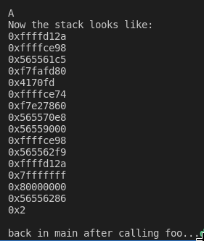

The objective is to supply strings of increasing length until we overwrite the return address that is being used to return back to main. With 15 “A” characters provided to the program, the buffer of size 10 is being overwritten to the point of the return address being overwritten:
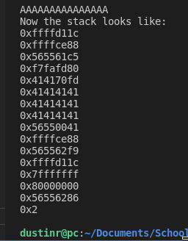

We can force the program to redirect control flow to an address of our choosing. In this case, we wish to call the function bar. The address of bar is provided by the output of the program:

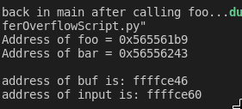

The memory address of bar in hex form is 565561B9. If we wish to overwrite the return address inside of foo with the address pointing to bar, we can pass the address into the program as hex using the following python script:

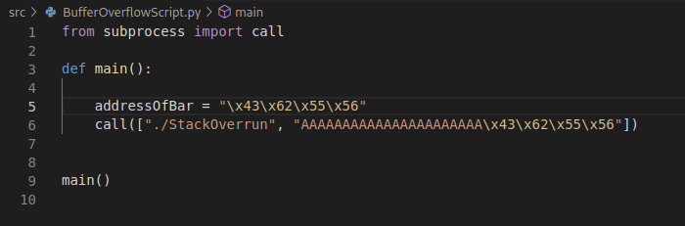

We append the hex address of the bar function to the end of the 15 “A” characters that we have provided in reverse order due to the little endian architecture of the intel x86 ISA, which gives us the following:
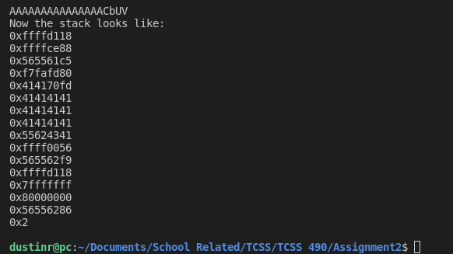

Notice that the output of bar is not yet generated by the program. This means we must push the return address of bar further into the program in order to fully overwrite the return address to main. We append 7 more “A”s to the end of our character string, which
gives the following:

GCC: Borland C++ :
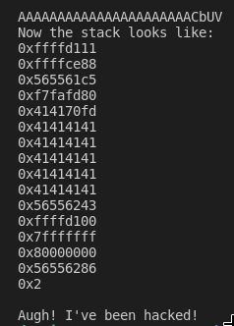
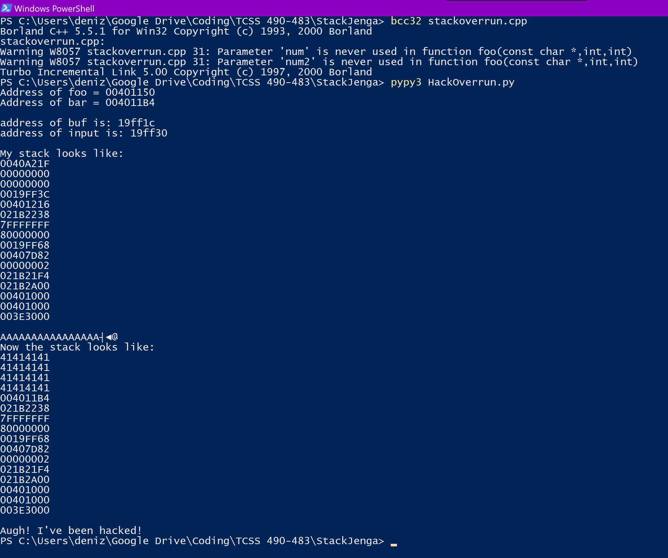

We have shown how to overwrite the return address to main in a given function by overflowing a buffer that accepts external input using unsafe functions in C like strcpy.

We proceed further to demonstrate how a payload can be passed into the program that causes it to execute arbitrary code.

In this setting, the objective is to deliver a payload that causes interruption to the control flow of the program and results in a shell being spawned during execution. A traditional method to achieving this result would be to encode a C executable containing arbitrary instructions as machine code. Next, the machine code is pushed into the buffer like above, but it is also necessary to find and include the memory address of that machine code so that when the return address in the vulnerable function is overwritten, the address called instead will route control flow back to the injected machine code and execute the arbitrary instructions contained within. It is important to note here that raw C code cannot be injected in this way, machine code native to the executing ISA must be used instead.

An alternative method that is more compact and portable, is to compile the payload externally, and pass it in to the vulnerable program as an environment variable. This is known as the Eggshell Method.

The Eggshell Method
https://www.tenouk.com/Bufferoverflowc/Bufferoverflow6.html

The Eggshell method works to contain the entire process of finding the return address of shell code inside of one executable. Setting this executable to an environment variable allows it to be passed into the vulnerable program with ease. It is then only a matter of finding out how many bytes are needed to overwrite the return address in the vulnerable program in order to achieve arbitrary code execution.

Assuming a supplied buffer size, the following code finds the return address to be used for the payload:
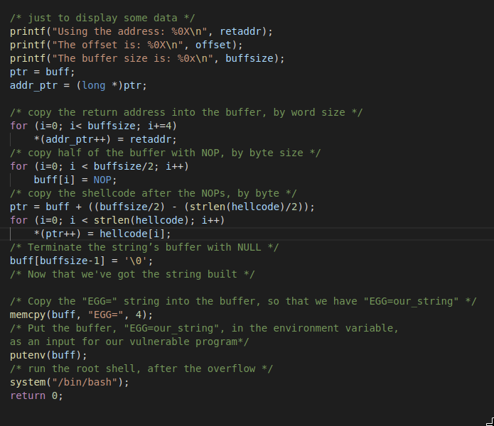

When this code is compiled and executed, the environment variable EGG is created. Now, it is possible to run the StackOverrun program and pass in the environment variable EGG as the following:
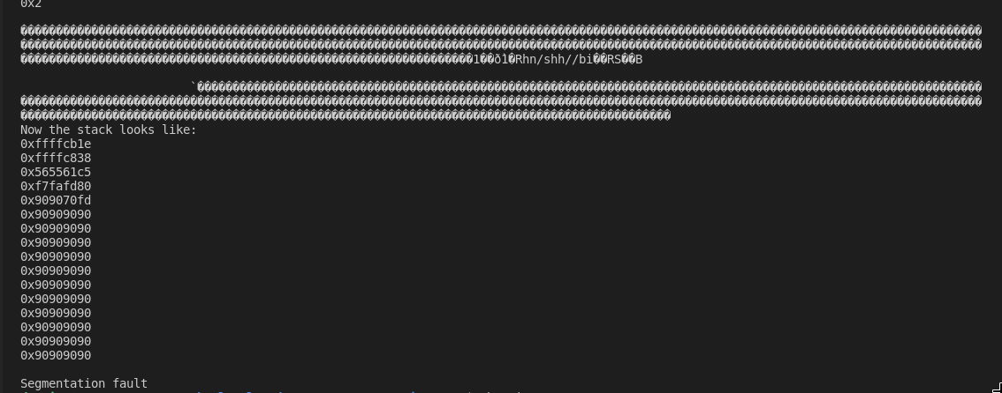
And the following occurs:

The environment variable EGG has been pushed into the buffer and has overwritten the return address to main, but the size of the payload has also interrupted the execution of the program and resulted in a segmentation fault.

Increasing the size of the buffer in the eggshell executable to 800 results in the following:
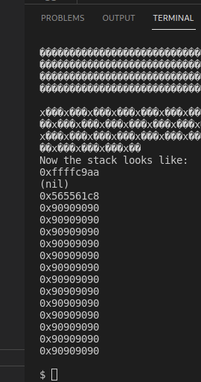

We conduct a test of some basic terminal operations:

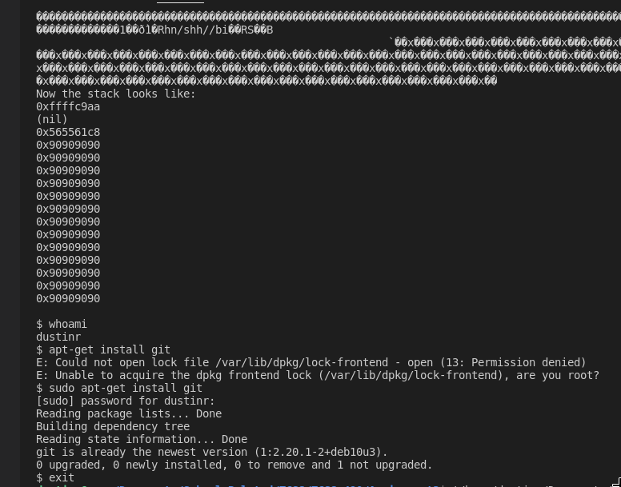

We have spawned a shell by passing in a payload to the vulnerable program. Source code is included with this submission. The buffer overflow attack is one of the most widely exploited vectors of attack directed at software written in the C programming language. Given most operating systems and programming languages are written in C, the importance of protecting against this form of attack cannot be understated.

References:

https://security.stackexchange.com/questions/186506/how-does-gcc-compiler-guard-stack-for-stack-overflow
http://www.kernel-panic.it/security/shellcode/shellcode5.html
https://opensource.com/article/19/5/how-write-good-c-main-function
https://radareorg.github.io/blog/posts/payloads-in-c/
https://www.tenouk.com/Bufferoverflowc/Bufferoverflow5.html
https://www.exploit-db.com/shellcodes
https://www.exploit-db.com/shellcodes/49770
https://www.exploit-db.com/shellcodes/49768
https://samsclass.info/127/proj/p3-lbuf1.htm

Source is found at:

https://github.com/dustinvonsandwich/Buffer-Overflow-Proof-Of-Concept

Team members:

Brandon Rosario
Dustin Ray
Kittera McCloud

